Transformational Workshops For The 21st Century



Science of Achieving Peak Performance and Massive Success

SHUBHA-WAY DEVELOPMENT ACADEMY
The Success Curve for your Business
Training-Coaching-Consulting-Family Counselling

Our Profile:

- Founded in 2019, by Mr.Subhash Wangde, Shubhaway development academy strives to help you achieve your goals, big and small.

- We help small business owners,CEO’s,Soloprenuers,and Students, Corporate Professional to understand and unleash their highest potential through the use of mind tools & techniques which in turn helps those live happier, healthier and more successful lives. This helps them to double their business while freeing their time and involvement.
We, at SHUBHAWAY DEVELOPMENT ACADEMY strongly believe that one can learn to achieve Peak Performance and Success through a well-defined System.

All Humans are equally powerful. The only difference is some of them have learnt how to TAP into their Inner Potential to become SUCCESSFUL while others have no idea of how to use this POTENTIAL.

Our conviction comes from the experiences of THOUSANDS of participants who have seen their life TRANSFORM after attending our PROGRAMS.

SHUBHAWAY DEVELOPMENT ACADEMY is focused on conducting TRANSFORMATIONAL WORKSHOPS for Successful and Happy living in the 21st Century.

All are participants believe that “NOTHING IS IMPOSSIBLE” because they are empowered with cutting edge Tools and technologies to break any LIMITING BELIEFS or Past Conditioning

- We have developed following areas:

  - Mind Power Unlimited for Public
  - Super Student Unlimited for students
  - Unleash the power within for Corporate’s
  - Stress Free Living
  - One on One Family Counselling using DMIT

Vision:
To inspire, motivate, and empower 10 Million people to live happier, healthier, and more successful live by 2032.

Mission:
- To make a difference to the lives of thousand by empowering them with tools and techniques to live happier, healthier & more successful lives.

- To touch, transform and help people to live their life fully to achieve their dream and vision by exploring and using their highest potential by Coaching, training, mentoring and counselling by using Mind Power technique, Soft Skills Programme, Business Consultancy to take their life to the next level in terms of success and abundance.

- This can be achieved by conducting Workshop, Seminars, Training, Classroom Coaching, Online Coaching, One to one coaching, family counselling, group consulting, You tube, Facebook , social media.etc.

Mind Power Unlimited for Public

Workshop Content:

- What makes Successful people successful?
- Detailed explanation of how the Mind Works, Types of Minds, Differences and various Powers of the Mind
- Success Principles
- Identifying Your Life Purpose and Living On Purpose
- Designing your Life in alignment with Your Core Purpose
- How to Set Balanced and SMART Goals in all areas of your life
- Alpha State Mind Programming
- Goal Achievement through the Powers of your Subconscious Mind
- Power of Thoughts and how they create our Destiny
- Power of Beliefs, Identifying and overcoming limiting beliefs
- Law of Attraction
- Confidence Building techniques (NLP Technique)
- Mind Programming Techniques such as Relaxation, Visualization & Auto-Suggestions / Affirmations, Mind Movies, Vision Board
- Negativity Removal and creating a Psychic Shield for protection from negative influences
- Emotional Freedom Techniques for re-wiring your brain and for removing emotional blockages and negative patterns that stop us from achieving our Goals
- Emotional Freedom Techniques for removing Physical Pain
- Sound Decision Making through Inner Guidance
- Living a Healthy, Stress Free life without any medicines
- Healing yourself and others
- Wealth Creation
- Weight Management (Reduce / Increase Weight)
- Attracting the right people into your life (Life Partner, Employer, Business Partner, and Employees & Clients)
- Finding the Ideal Job
- How to program your child to become a super child
- Sleep Management, Mental Alarm, Power Nap
- Pain Control
- Scoring well in examinations, performing well in Interviews
- Negotiations, Ability to convince others
- Excel in Sports
- Attract Healthy and Happy relationships at Home and Work
- Problem Solving and develop Sound decision making abilities
- Enhancing Creativity, Innovation
- Phobia Removal
- Enhance your Emotional and Spiritual Quotient
- Get rid of any harmful habits/addictions (Smoking, Alcohol, etc.)

These exercise will shatter your limiting beliefs and make you UNSTOPPABLE.
This workshop is designed to help you create a BLUEPRINT FOR SUCCESS in your Personal and Professional Life. We will teach you timeless SUCCESS Principles and Mind Power Tools and Techniques which will ensure you get from “WHEREVER YOU ARE NOW to WHEREVER YOU WANT TO BE”, faster than ever before.

What would you like?

- Double your income?
- Double your free time?
- Create happy and fulfilling relationships?
- Heal yourself or keep yourself fit all your life?
- Be happy and experience Inner peace and joy?
- Achieve financial freedom?

You can actually create your own future. As the saying goes, "The best way to predict future is to create it". Swami Vivekananda said “You are the Architect of your future”; “Your destiny is in your hands only”. This workshop is all about learning how you can actually create a life of your dreams.

Who should attend the workshop?
Business People, Sales People, Housewives, Professionals, Students, Senior Citizens

Workshop-Super Student Unlimited for Students

Background:

There is no better time in History than today. The 21st Century brings
In a plethora of opportunities. Such opportunities never existed before.
However, with the opportunities come several challenges as well.
Parents and Students are faced with challenges today that they never
Faced before:

Some of the challenges faced by Parents and Students are:

• Changing family structures (Nuclear / Atomic families) leading to lack of social support systems
• Strain in Parent / Child Relationships
• Rapidly changing Educational Systems
• Information becoming outdated at an extremely fast pace
• Intense competition
• Knowledge based economy making it necessary for students to be well educated
• Escalating costs of education
• Peer pressure (material objects, boyfriends/girlfriends, etc.)
• Career selection – too many options
• Stress faced by parents in coping up with finances
• Rising educational costs
• Information overload – Print and electronic media, Social media, Internet, etc. leading to confusion
• Lack of confidence, concentration and focus due to stress
• Lack of Clarity of Goals
• Exam stress
• Substance abuse (smoking, alcohol, drugs)
• Pre-marital sex and sexual abuse

And many more…..

Historically, human beings have always survived and raised above all the challenges by using more and more of their inner powers (hidden potential/mind power). Our founder, Mr. Subhash Wangde believes that the only way for Parents and Students to live a happy and successful life is to harness the inner potential that all human beings have and create a life of their choice.

Unfortunately, this education is amiss in traditional educational systems. The life and mind skills that are necessary to tap into our infinite human potential are non-existent. It is looking at this necessity, that we at SHUBHAWAY, have developed this workshop “Super Student Unlimited”.

Program Highlights:

This workshop is all about student empowerment. It focuses on making the participants aware of the enormous potential that exists within every human being and how one can tap into this potential using a simple system that is used by all successful people, knowingly or unknowingly.

This workshop uncovers a scientific system for achieving any goal and solving any problem. The tools and techniques taught in this experiential workshop will enable its participants to “Unleash the Power Within” and become UNSTOPPABLE.

We teach techniques which allow the participants to breakthrough any barriers or limiting beliefs or childhood conditioning which holds one back from achieving their goals and vision. All participants go through a complete transformation which opens up endless possibilities for them, which they could not have imagined earlier.
This 2-day workshop will take the participants through an extraordinary transformational process that will bring about a change at a cellular level so that results are permanent!

Program Benefits / Outcomes:

• Complete Goal Orientation – Clarity of what they want to do in their lives.
• Identifying their true inner qualities and developing them
• Understanding of their hidden potential
• Learning Mind techniques for Goal achievement and problem solving
• Higher Emotional quotient (ability to deal with emotions) and Spiritual
• Quotient (better understanding of self)
• Improved performance in exams and sports
• Higher focus and concentration
• Improved memory
• Improved relationships with parents, siblings, friends, etc.
• Ability to cope with exam stress or any other form of stress
• High level of confidence
• Ability to deal with peer pressure and addictions
• Improved health and wellbeing

And an overall shift in attitude… The student will be completely empowered to
Achieve whatever they wish to achieve in his/her life.

Workshop-Stress Free Living

Challenges of the 21st Century
• Sedentary lifestyle / Less Physical Activity
• Improper Eating Habits
• Improper Sleeping Habits
• Smoking, Alcohol, Substances
• Change in Family Systems
• Fierce Competition
• Inflation
• Generation gap
• Demands / Expectations and many more..

Stress is becoming the biggest challenge……
Let’s understand Stress
Stressors within you…
- One Track Mindedness
- Perfectionist
- Not willing to forgive & forget
- Attempt to please others
- Unrealistic Expectations
- Not willing to change / inflexible
- Less / Improper Sleep
- Always Submissive
- Cannot say NO
- Irrational Beliefs
- Workaholic
- Bottle Up Feelings, Dissatisfaction with self
- Poor Nutrition / Exercise
Stressors outside you…
- Recent illness
- Divorce
- Retirement
- Changing jobs
- Child birth
- Death in family
- Major financial loss
- Accident
- Home /marital problems
- Work related issues
- Responsibilities towards your spouse /children
- Responsibilities towards your organization
- Poor Environment
- Poor Time Management

Hence, learning how to Manage Stress is the Key to Successful and Happy Living:
1) EFT (Emotion freedom technique)
• EFT Stands for Emotional Freedom Techniques
• It is a combination of Chinese Acupuncture and Modern Psychology Hence it can be called “Psychological Acupuncture”
• Non Invasive
• Use to remove effects of Negative Emotions / Past Negative Experiences which cause stress

2) Relaxation technique
3) Power Nap
4) Practice of Mindfulness:
- Law of attraction/Vibration
- Power of thought
- Unlimited Mind Power
- Visualization technique
- Affirmation technique
- Gratitude & Appreciation
- Forgive & forget
- Meditation
- Taking 100% responsibility of your own life
- Regular exercise
- Proper nutrition diet
- Daily rituals

Workshop-Unleash the Power Within for Corporates

Background:

There is no better time in History than today. The 21st Century brings in a plethora of opportunities.
Such opportunities never existed before. However, with the opportunities come several challenges as well. Organizations are faced with challenges that they never faced earlier. Some of the challenges are:

- Significant competition at a global level
- Increasing customer demands and service requirements
- Immense pressures of rising costs (payroll, real estate, power, etc)
- Customer’s demand of getting more for less constantly changing global environment (stock market and currently fluctuations, economic factors, etc.)
- Impact of globalization – businesses getting impacted by changes in any part of the world
- Keeping the workforce motivated and energized to manage attrition
- High level of stress faced by workforce on maintaining schedules, work pressures and also balancing work and life thereby affecting their ability to produce desired results
- Necessity to constantly innovate in order to survive
- The need for corporate leaders to take sound decisions and solve problems quickly
- Alignment of employees to the central vision and mission of the organization
- Team Dynamics and many more…

Historically, human beings have always survived and raised above all the challenges by using more and more of their inner potential.

Our founder, Mr. Subhash Wangde strongly believes that the only way for corporate leaders to run large organizations successfully, is to harness the inner potential that all human beings have.
It is looking at this necessity that we at SHUBHAWAY have developed this workshop “Unleash the Power Within”.

Unfortunately, this education is amiss in our educational system. The life and mind skills that are necessary to tap into our infinite potential are non‐existent. It is looking at this necessity that we at SHUBHAWAY have developed this workshop “Unleash the Power Within”

Program Highlights:

This workshop is all about empowerment. It focuses on making the participants aware of the enormous potential that exists within every human being and how one can tap into this potential using a simple system that is used by all successful people, knowingly or unknowingly.

This workshop uncovers a scientific system for achieving any goal or solving any problem. The tools and techniques taught in this experiential workshop will enable its participants to “Unleash their Power Within” and become “UNSTOPPABLE”.

We teach techniques which allow participants to breakthrough any barriers or limiting beliefs or pastexperiences which holds one back from achieving their goals and vision. All participants go through acomplete transformation which opens up endless possibilities for them, which they could not have imagined earlier.

This 2‐day workshop will take the participants through an extraordinary transformational process that will bring about a positive change at a cellular level so that the results are permanent!

Program Benefits / Outcomes:

What are the critical outcomes / benefits?

● an empowered and a motivated workforce
● Understanding and realization of the Power within
● The process of tapping into the vast inner potential for goal achievement
● Learn how to overcome disempowering limiting beliefs / limitations of the past
● Sound decision making and problem solving capabilities
● Ability to deal with stressful situations
● Enhanced right brain / creative thinking abilities
● Better ideating / innovating capabilities
● Positive approach to Work and Life
● Improve team dynamics and align people to company’s central vision and mission
● Increased focus and concentration leading to higher
● Improved health and wellbeing
● Higher Emotional and Spiritual Quotient
● Increased confidence levels
● Learn powerful mind techniques for negotiation / convincing abilities
● Improved customer service and customer relations

The Workshop will have several practical Breakthrough Exercises such as

● Fire Eating
● Hand Magnetism
● Body Stiffening
● Lifting a Person with Two Fingers
● Needle Piercing
● Pendulum Dowsing (for decision making)... and much more to help the participants to breakthrough their limiting boundaries!

One on One Family Counselling using DMIT:

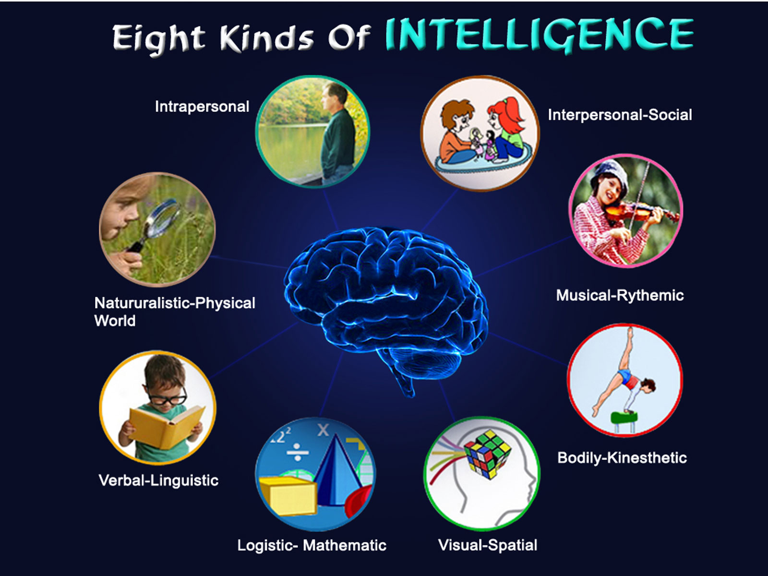

Multiple Intelligence:

We have multiple intelligences e.g. logical, linguistic, intrapersonal, interpersonal, etc.
So DMIT is a sophisticated technology used to understand the Multiple Intelligences of a person through their fingerprint patterns.

- Fingerprints are Unique. No two individuals have the same fingerprints.
- Fingerprints and Brain Development happens simultaneously between the 13th to 21st week of pregnancy
- Scientists have discovered that there is a co-relation between the brain development and the fingerprint patterns
- Fingerprints don’t change in one’s entire lifetime.

Did you know?

- The Pattern of the fingerprints doesn’t change & that is absolute way to find the inborn talent of you and your child.
- Every child is Unique & born Genius
- Every child has 8-types of Intelligence Skills
- Your child could be a left Brain thinker or Right Brain thinker

DMIT helps you find out….

- Your child’s Inborn Intelligence
- Your child’s learning pattern
- Whether your child is logical or creative
- How your child memorises information
- Your child’s areas of interest or activities
- Which career your child is likely to excel in
- Your child’s Personality Type
- Your child’s Inborn Potential

Chief Counsellor:

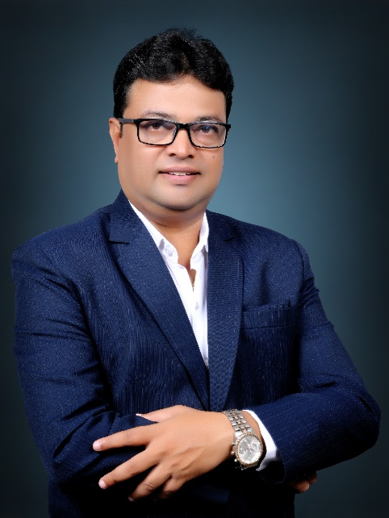
Subhash Wangde, Certified Mind Power Trainer, Counsellor and Author.
The Mind can be man’s best friend or it can be man’s worst enemy. The Mind can make or break a person. Yet, there is very little taught in schools or colleges on how to use our Minds effectively.
Subhash Wangde, an Electronics & telecommunication Engineer from Mumbai University, is India’s leading Mind Power Expert. He started his journey of understanding the mind and its potential in 2019. Today he teaches people how to effectively use their minds for living happier (stress free), healthier and more successful lives. He also teaches individuals how to develop a positive mindset which believes that “Anything is Possible” He chose to give up his lucrative corporate career after working for 22 years to follow his passion of making a difference to people’s lives. Over the past 4 years, he has conducted many workshops, seminars, keynote speeches and motivational talks and has touched over 10,000 lives across India.
Subhash, firmly believes that to thrive in the 21st Century, human beings need to use more of more of their inner potential i.e. their minds. By effectively using their Inner Potential, human beings can achieve any goal and solve any problem. In short, he believes that all the solutions exist INSIDE and not OUTSIDE. All his work is focused around understanding and using the unlimited potential within.
Subhash is a Certified Transformational Coach, Mind Power Expert & International Business Coach. Above all, he has been personally trained by America’s leading Success Coach, Mr. Jack Canfield, co-author of the international best seller “Chicken Soup for the Soul” and The Success Principles”.
He conducts public workshops, corporate workshops (Stress Free Living, Sales and Leadership Mastery, Personal effectiveness and more), keynote speeches, motivational talks and also coach’s celebrities, business people, sports people and people from all walks of life.
His workshops are transformational in nature and brings about a significant shift in the participants mindset and attitude towards life and work.
He is also an International Best Seller Author of his book “SMALL STEPS, BIG GROWTH”
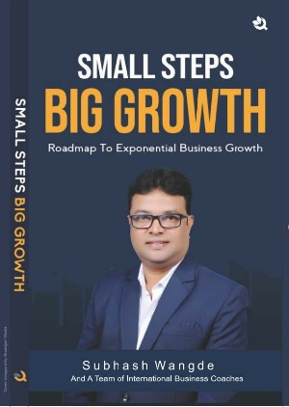

Shubha-Way Development Academy
Training-Coaching-Consulting-Counselling
(M) 7875506912, E-mail-subhash.wangde@gmail.com
Web: www.subhashwangde.com

